
North Bengal International University

Lab Report: 04
Exp Name : Water Jug Problem Solver using BFS

Subject : Artificial Intelligent sessional
Subject Code : CSE 0613-3112

Submitted By:
Name : Md. Tanvir Rahman Pranto
Dept : CSE
Roll : 0712340012101005
Semester : 3nd Year, 5th semester.

Submitted To:
Name : Rifa zumana
Designation : Lecturer
Dept : CSE
Date :

Tittle: Water Jug Problem Solver using BFS
Theory: This Python code solves the Water Jug Problem using Breadth-First Search (BFS).
It explores all possible states of two jugs (capacities m and n) to reach exactly d liters.
Each state is a tuple (a, b) representing current water levels.
The algorithm tracks visited states and reconstructs the path once the goal is found.

Code:
from collections import deque

def water_jug (m, n, d):
start = (0, 0)
q = deque([start])
visited = {start}
present = {start: None}

while q:
a, b = q.popleft()
if a == d:
path = []
cur = (a, b)
while cur is not None:
path.append(cur)
cur = present[cur]
return path[::-1]
for ns in [(m, b), (a, n), (0, b), (a, 0), (max(0, a + b - n), min(a + b, n)), (min(a + b, m), max(0, a + b - m))]:
if ns not in visited:
visited.add(ns)
present[ns] = (a, b)
q.append(ns)
return None

if __name__ == "__main__":
m, n, d = 4, 3, 2
result = water_jug(m, n, d)
if result:
print("steps to get", d, "liters of water:")
for step in result:
print(step)
else:
print("no solution")

Output:
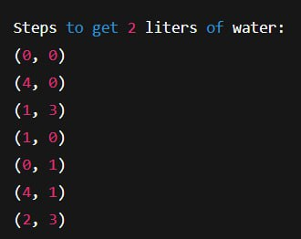

Conclusion: BFS guarantees the shortest path to reach the desired water amount. If a solution exists, it prints the step-by-step jug states leading to d liters. If not, it returns "no solution". This method is efficient and reliable for jug problems

